**Ma’lumotlar tuzilmasi va algoritmi**

**F.I.SH. _Omonbayev Jaloliddin**

**Guruh: _911-21 guruh talabasi_**

**Amaliyot: _2**

**Misol: _7**

**Dasturlash tili: _C++ online compiler**

**Savol:**

Xotira limiti: 64 MB

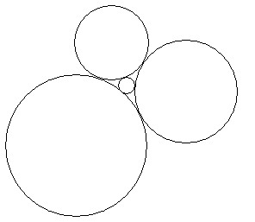

To’rtta aylana xuddi rasmda ko’rsatilgandek bir-biriga urinadi. Agar 3 ta katta aylana radiusi *a, b, c* bo’lsa, to’rtinchi aylananing radiusi qanchaga teng?

**Kiruvchi ma’lumotlar:** uchta butun son: *a, b, c* – katta aylanalar radiuslari (1 ≤ *a, b, c* ≤ 1000).

**Chiquvchi ma’lumotlar:** To’rtinchi (eng kichik) aylana radiusi. Javobni 10-6 aniqlikda chiqaring.

|  |  |  |
| --- | --- | --- |
| **№** | **Kiruvchi ma’lumotlar** | **Chiquvchi ma’lumotlar** |
| 1 | 1 2 3 | 0.260870 |

**#include <iostream>**

**#include <cmath>**

**using namespace std;**

**int main()**

**{**

**double r1,r2,r3,r4,a,b,c,P,Lc;**

**cout<<"Iltimos radius qiymatini << 1<=r1,r2,r3<=1000>> oraliqda kiriting!!!"<<endl;**

**cout<<"r1=";**

**cin>>r1;**

**cout<<"r2=";**

**cin>>r2;**

**cout<<"r3=";**

**cin>>r3;**

**if(1<=r1 and 1<=r2 and 1<=r3 and 1000>=r1 and 1000>=r2 and 1000>=r3) {**

**a=r1+r2, b=r2+r3, c=r1+r3, P=r1+r2+r3;**

**Lc=2/(a+b)*pow((a*b*P*(P-c)),1./2);**

**r4=((Lc-r2)*(r1+2*r2+r3)-(r1+r3)*r2)/(2*(r1+r2+r3));**

**cout<<"r4="; printf("%.6f",r4);**

**}**

**else{**

**cout<<"<<Qaytadan qiymat kiriting>>";**

**}**

**return 0;**

**}**

